Level 9 -> Level 10

The goal of this level is to find the pass to log into <http://natas10.natas.labs.overthewire.org>.

Username: natas10

After logging into level 9 we got a hint to get the password of next level. **There is a link to view the source code.** So, simply click on the link to view page source.

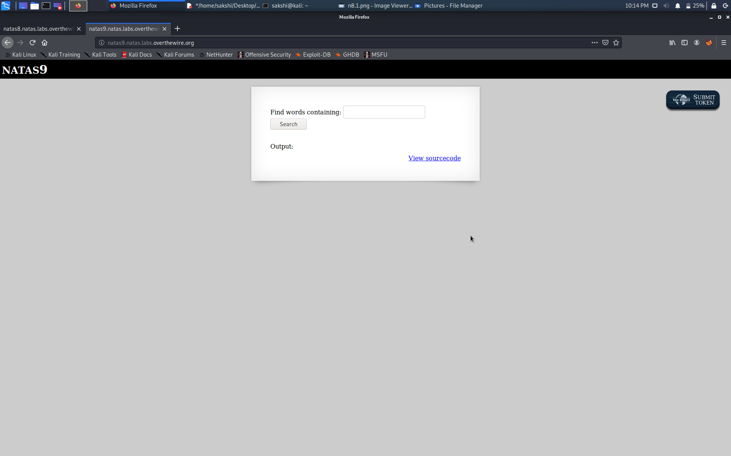

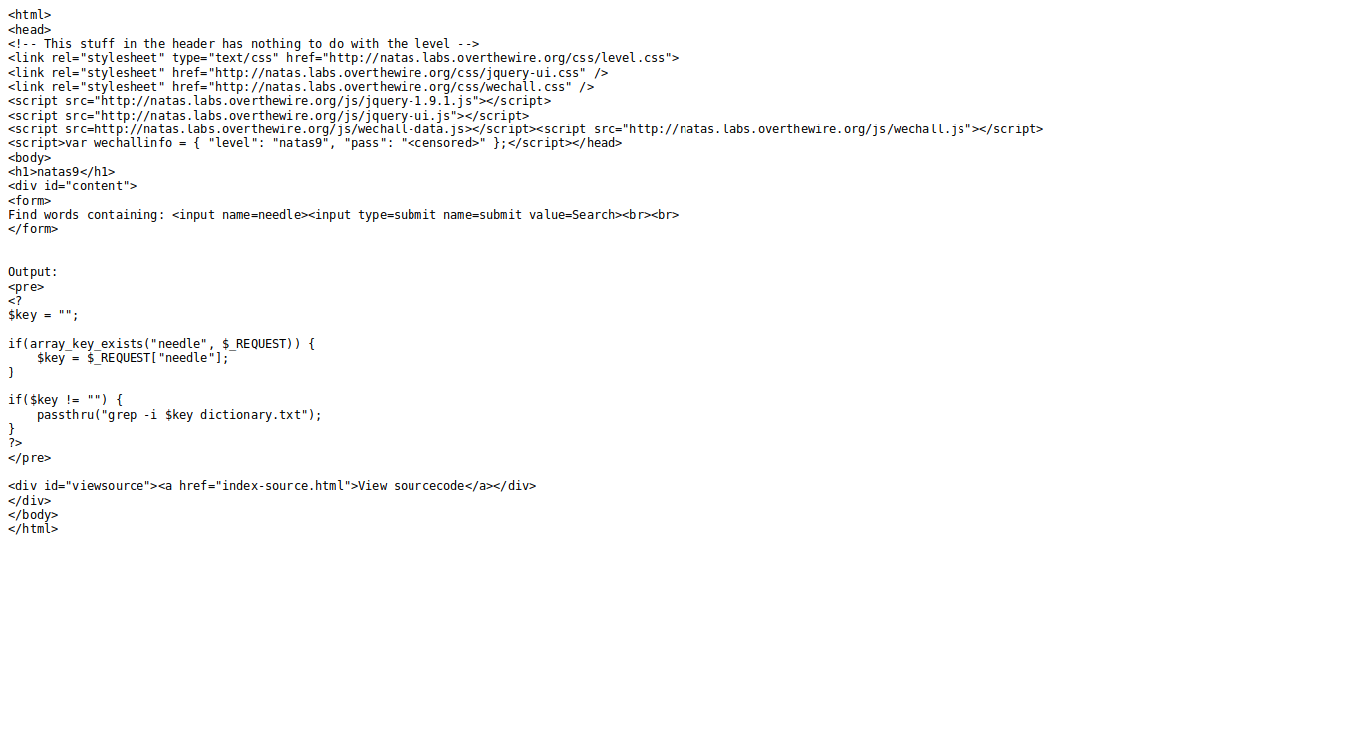

In source code we found that when we enter a keyword, it is passed via a function called passthru(). It takes the value in $key and executes it directly. So, we will use (;) to execute multiple commands. We will try to read the password at the next level.

**We will use this- ;cat /etc/natas_webpass/natas10** as we know all the passwords are in the /etc/natas_webpass directory.

When we enter the above command in the input box it will got to the passthru() function. And the command that will execute is **“grep -i ;cat /etc/natas_webpass/natas10 dictionary.txt”**

* **Grep -i will terminate because of semicolon(;) and then cat /etc/natas_webpass/natas10 will execute and the dictionary.txt**

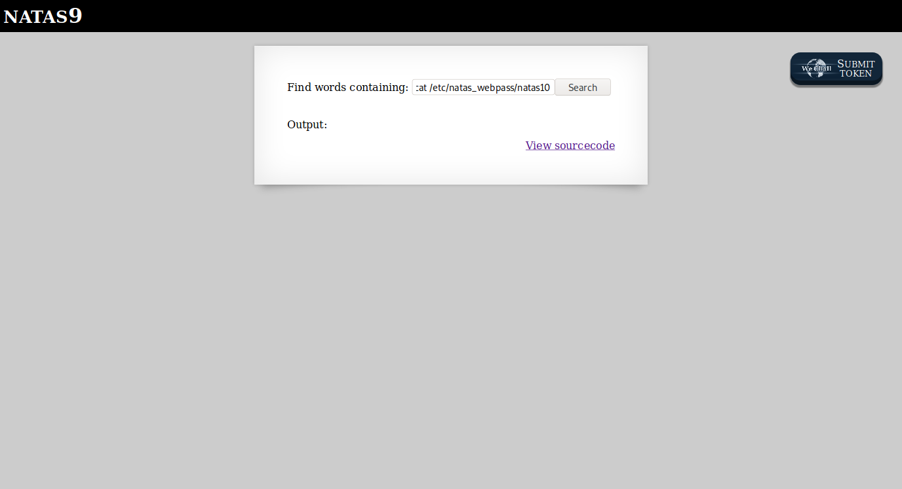

And here is the password…

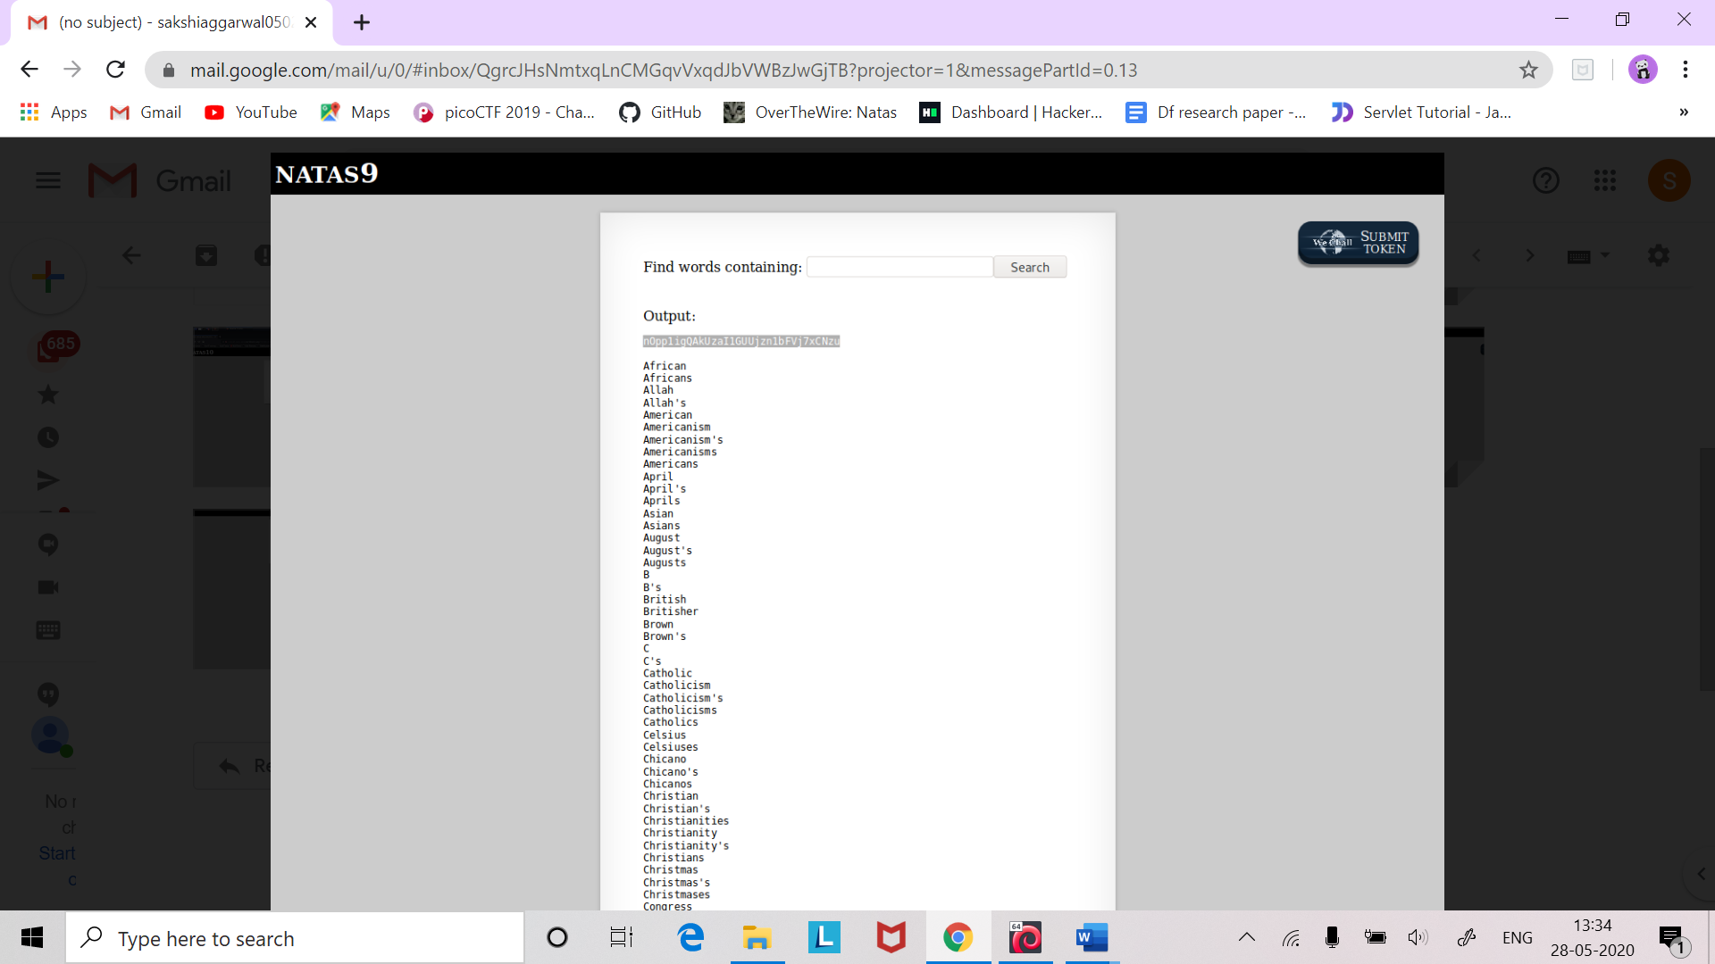

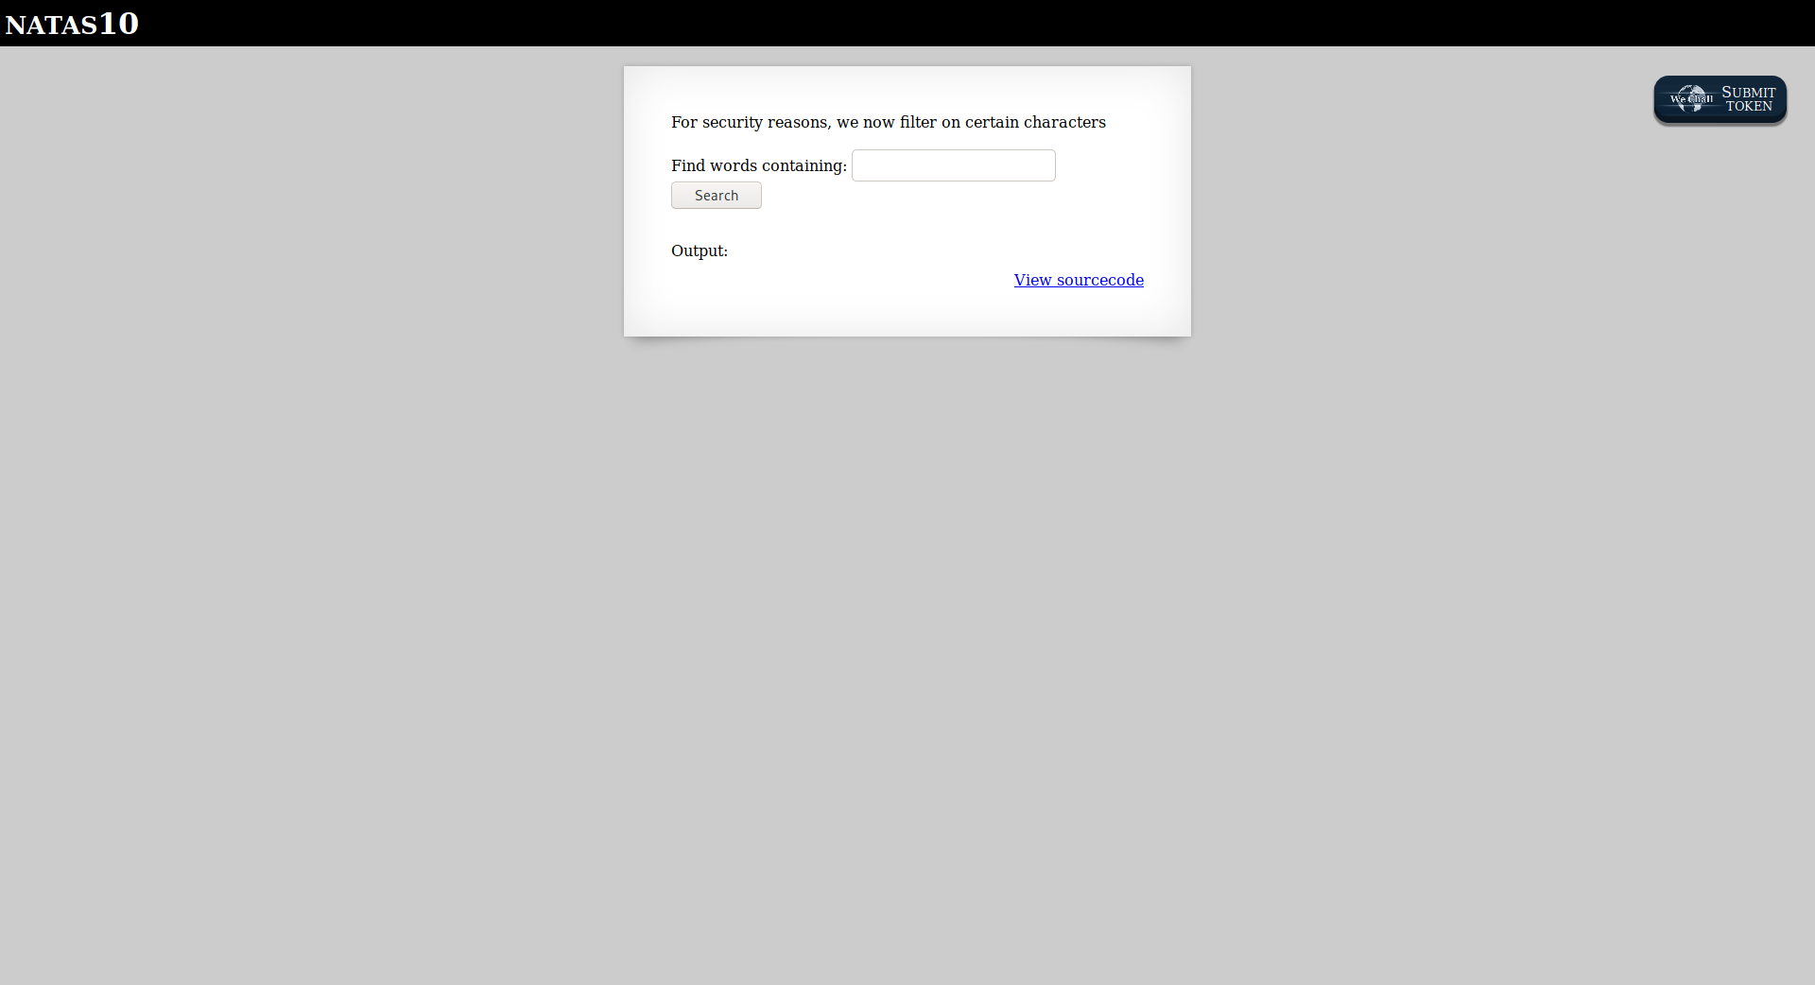

Successfully passed level 10.… 